Binary Trees

Purpose: In this lecture series we will learn about Binary Trees.
Binary Trees are another type of Data Structure that may be implemented using Java’s TreeSet or TreeMap. Most Binary Tree operations carry an efficient Logarithmic run time behavior.

Resources: Java Methods AB Data Structures Chapter 5 p.115
Java Essentials Study Guide Chapter 17 p.314 to 330 &
Chapter 20 p.387-398
Barrons Chapter 10 p.328 & Chapter 11 p.378-384
AP Java Text Chapter 19 and Chapter 20 p.883-889

Handouts: 1. Java Classes And Interfaces:
TreeSet
TreeMap
2. TreeNode Class
3. Sample Code (TreeSetAndMap.java & Portions of BSTClass.java)
4. HSA Package (used to Illustrate Tree behaviors)
5. Posted Code Examples:
CreateTree.java
OutPutTrees.java
TreeInsert.java
SearchTree.java
TreeDelete.java
6. Starter code for writing your BST Class
BSTClass SPVM Part.java
7. JESG Comparator p.327-330 & p.397-398
Intro:
What we Will Cover in This Lecture:

Another Look at Collections
Binary Tree Described
Binary Search Tree Defined
List of a Trees required Behaviors
TreeNode Class

Calculation of a Trees Depth
Calculation of a Trees Width

Creating our Own Binary Tree (completed in a Lab)
Tree Traversal (InOrder, PreOrder and PostOrder)
Insert into a Tree
Search for an Object in a Tree
Remove an Object from a Tree (3 situations)

TreeSet Class
TreeMap Class

Big-O of a Binary Tree
Review Various Barrons Examples
The AP AB Requirements

The Collections Interface

Lets focus on the Collection Hierarchy and then, LATER, we will look at the TreeMap and TreeSet Java Classes

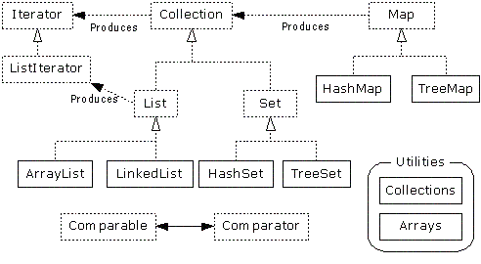

Please note that TreeSet. LinkedList, HashSet and ArrayList all have ISA Collection
relationship

As a result, we can perform the following data manipulation:

Set s = new HashSet();

// add elements to the Set

// remember that a TreeSet is a Collection !!!
Set t = new TreeSet(s);

Notice how the initial reference is a Set (interface)

This allows for dynamic associations of this reference with any object that implements Set
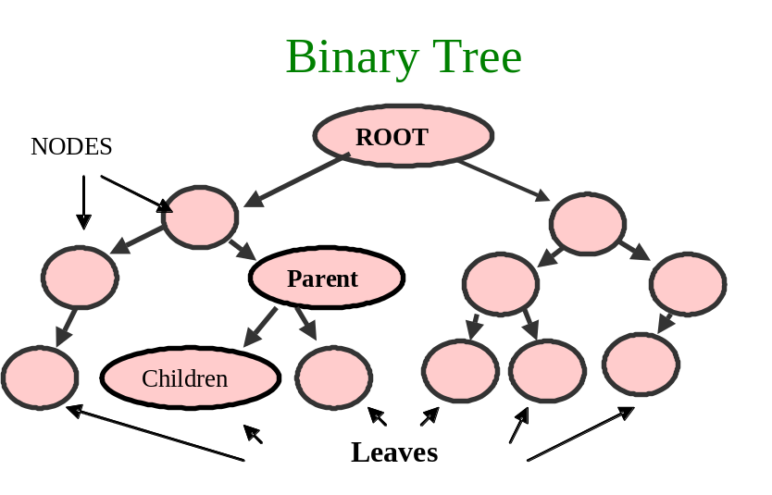Binary Tree Described

A TREE is a branching structure where each element EXCEPT THE TOP ONE has a relation to exactly one element higher in the hierarchy called its PARENT

Elements of a tree structure are referred to as NODES

TOP node is called the ROOT of the tree

Any tree node can be connected to 1 or more nodes LOWER in the hierarchy --- they are called CHILDREN

LEAVES are nodes that have no children

Intermediate nodes in this path are referred to as the nodes ANCESTORS

Trees may not have circular paths as NO child can REFER back to Their/Any parent

All nodes in a tree can be arranged in layers with:

the root at LEVEL 0
Its children at level 1
Their children at level 2…

The LEVEL of a NODE is equal to the length of the path from the root to that node

The total number of LEVELS is called the HEIGHT or the DEPTH of the tree

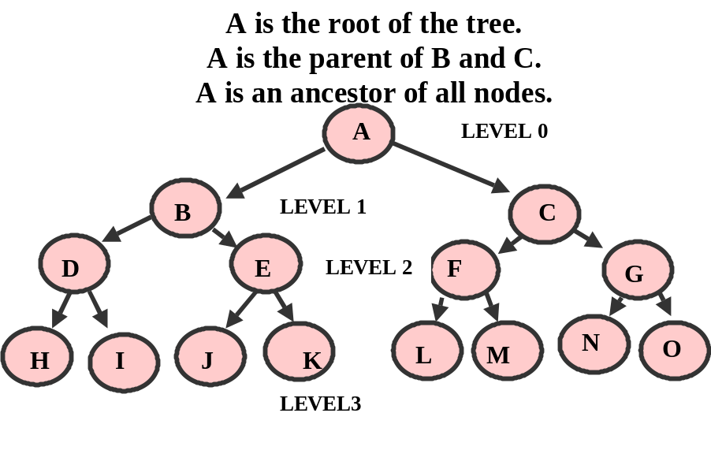The Height of a Tree is the Number of nodes in the longest path from the root to a leaf of the tree ( or 1 more than the depth or level of the Tree)

The height of the empty tree is 0
The height of a single node tree is 1 (Level 0)

Trees can arrange a large number of elements in a relatively SHALLOW tree

A tree with h levels may contain (2 to the h) –1 nodes:

A tree with 20 levels contains over 1 million nodes

The previous illustration contains 15 nodes in 4 levels or a tree height of 4
(2 ^ 4) - 1 = 15

As a result of its shallow nature, trees can be quickly searched & data can be retrieved

Instead of traversing an entire linked list and examining ALL the elements, we can traverse the tree and examine only a few nodes.

LIKNED LIST Connection:

A list can be viewed as a special case of a tree where the FIRST node is the ROOT
And the last node is the only leaf
AND all other nodes have exactly one parent and one child

A list has only one node at each level

With LINKED LISTS:
Each node holds the list of references to its children

A tree is inherently RECURSIVE in nature as each node in a tree can itself be viewed as the root of a smaller tree

Illustrate this in the previous example where a node in level tree (having its own children) can be viewed as the ROOT of its own smaller subtree

In computer applications, trees are normally represented in such a way that each NODE “Knows” where to find all its children

Knowing only a trees ROOT we can find all the nodes of the tree.

Given any node, we can find all the nodes in its subtree.

Recursive branching structure of trees suggests the use of recursive procedures for dealing with them.

A BINARY TREE is a tree in which each node has no more than TWO CHILDREN

With a Binary Tree, its Children are called the LEFT CHILD and the RIGHT CHILD

Binary Search Tree Defined

A BINARY SEARCH TREE (BST) is a structure for holding a set of ordered data elements in such a way that it is easy to find any specified element and easy to insert and delete elements

With a sorted array of elements “Divide and Conquer” binary search algorithm allows us to quickly find any array element

We take the middle element of the array, compare it with the target value and
If not equal continue searching the LEFT or RIGHT half of the array depending on the comparison result
Array weaknesses are with inserting or deleting array elements (in order)

A Linked List structure allows us to easily insert and delete nodes but the traversal must go node by node

BST’s combine the best of arrays and linked lists to allow for quick search, insertion and removal.

BST Properties:

Each node has no more than 2 children

Children are called the LEFT and RIGHT subtrees

For any 2 nodes we can say whether the first one is GREATER, EQUAL , or SMALLER than the second

For any NODE, the element in that NODE is LARGER than ALL elements in its LEFT subtree (EVERY NODE IN LEFT SUBTREE IS LESS THAN ITS PARENT’S NODE)

AND

Smaller than ALL elements in its RIGHT subtree (EVERY NODE IN RIGHT SUBTREE IS GREATER THAN ITS PARENT’S NODE)

50
25
75

Some BST’s permit duplicate elements while others do not

In a BST it is easy to find the SMALLEST and the LARGEST element:

To get to the SMALLEST ELEMENT:
Start at the ROOT
Go LEFT as long as possible, gets us to the NODE containing
The SMALLEST element

To get to the LARGETS ELEMENT:
Start at the ROOT
Go RIGHT as long as possible, gets us to the NODE containing
The LARGEST element
Looking at the Handout, start at the root (value 50) and identify the smallest and largest value node

Answer is 6 is smallest and 88 is largest

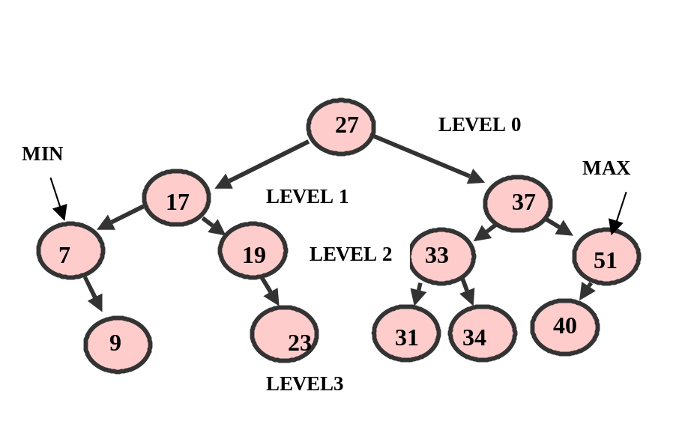Another Example:

A Balanced Tree exists when there are about the same number of nodes in all of the left
and right subtrees

Our previous example could be considered a balanced tree

Maintaining a balanced is critical if we are to maintain the logarithmic efficiency of most of the behaviors of a Binary Tree

Why ?

Because a Tree can degrade to linear efficiency if all nodes are on one side

For Example, if the first node added in the tree has a value of 51, every other node
inserted will be on the left side (we will see how this happens shortly)

A Full Binary Tree exists when every leaf node is on the same level and every non-leaf
node has 2 children

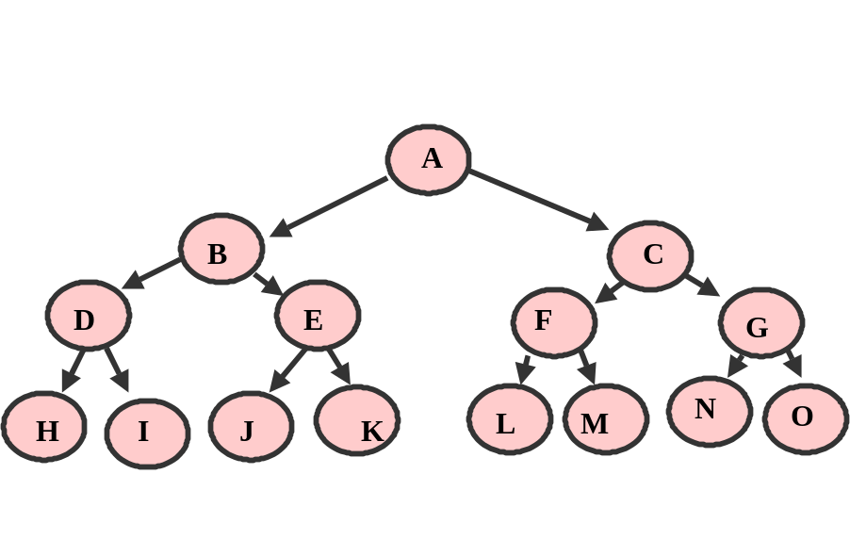A Complete Binary Tree exists when a tree is Full or when, at the last level, there is NO right child without a left child
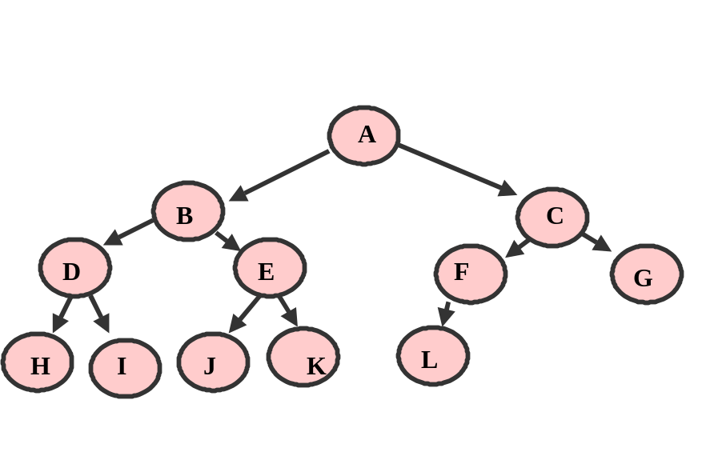

List of a Trees required Behaviors

In order to implement a Binary Tree, you need to provide for the following behaviors:

Traverse a Tree (Inorder, PreOrder and PostOrder)

Insert a node

Search for a specific element in the tree

Remove an element from the tree

TreeNode Class

Unlike a Linked List, there is no Binary Tree Class in Java

We will need to create our own Tree Class or utilize the TreeSet or TreeMap Java classes

Much like the Linked List, the College Board provides a node class called TreeNode that can be used to serve as the NODE for each element in a tree

The TreeNode class has class level attributes to maintain an Object as well as references to any Left or Right children

public class TreeNode
{
private Object value;
private TreeNode left;
private TreeNode right;

The Object in the TreeNode needs to implement the Comparable interface and code for the equals method (Integer and String class)

The constructor establishes the state of a node

public TreeNode (Object initValue, TreeNode initLeft,
TreeNode initRight)

The TreeNode is mutable and also provides appropriate accessor methods

public Object getValue ()
{
return value;
}
public TreeNode getLeft ()
{
return left;
}
public TreeNode getRight ()
{
return right;
}
public void setValue (Object theNewValue)
{
value = theNewValue;
}
public void setLeft (TreeNode theNewLeft)
{
left = theNewLeft;
}
public void setRight (TreeNode theNewRight)
{
right = theNewRight;

The TreeNode can be used in a BST Class to maintain the state of the ROOT of the tree

public class BST
{
private TreeNode root;

You access nodes in the tree FROM the root node

In the following WROTE example, we can build a Binary tree (AP Java p.812-814):

TreeNode root, n1, n2, n3, n4, n5, n6;
n1 = new TreeNode ("X", null, null);
n2 = new TreeNode ("Y", null, null);
n3 = new TreeNode ("H", n1, n2);
n1 = new TreeNode ("T", null, null);
n2 = new TreeNode ("U", null, null);
n4 = new TreeNode ("J", n1, n2);
n1 = new TreeNode ("V", null, null);
n5 = new TreeNode ("K", n1, null);
n6 = new TreeNode ("C", n4, n5);
root = new TreeNode ("A", n3, n6);

TPS: Draw the Resulting Tree
Determine the number of Levels & Min & Max Nodes

A (root)

H (n3) C(n6)

X Y J(n4) K(n5)

T U(n2) V(n1)

Calculation of a Trees Depth

The Depth of a NODE in a Tree is the length of the path from root of the tree to that node

In the previous Illustration:

node T has a Depth of 3
node H has a depth of 1
node A (root) has a depth of 0

So, a nodes depth is equal to its level

To determine the DEPTH of a TREE we determine the level/depth of its DEEPEST leaf

The depth of the tree in our example is 3

Call the following method (AP Java p.815-816):

SPVM…
System.out.println ("The depth is " + (getDepth (root) - 1));

private static int getDepth (TreeNode node)
{
TreeNode left, right;
int leftDepth, rightDepth;

if (node == null)
{
return 0;
}

left = node.getLeft ();
right = node.getRight ();
leftDepth = getDepth (left);
rightDepth = getDepth (right);

return 1 + Math.max (leftDepth, rightDepth);
}

RUN CreateTree.java for class

Calculation of a Trees Width

A Trees Width is the largest number of nodes found at a given depth

At depth 0, the width of the tree is 1

In the previous Illustration:

The trees width at node U (level 3) is 3
The trees width at node Y (level 2) is 4

Call the following method (AP Java p.816-818):

SPVM…
System.out.println ("The width at depth " + depth +
" is " + getWidthAtDepth (root, depth));

private static int getWidthAtDepth (TreeNode node, int depthToGo)
{
TreeNode left, right;
int leftWidth, rightWidth;

if (node == null)
{
return 0;
}

if (depthToGo == 1)
{
return 1;
}

left = node.getLeft ();
right = node.getRight ();
leftWidth = getWidthAtDepth (left, depthToGo - 1);
rightWidth = getWidthAtDepth (right, depthToGo - 1);

return leftWidth + rightWidth;
}

RE-RUN CreateTree.java for class

TPS: Write code to produce the Maximum width of a Tree

Creating our Own Binary Tree Class (completed in a Lab)

You will need to create a BST class that supports all of the required behaviors (create, insert, find, remove, traverse)

public class BST
{
private TreeNode root;

Your class needs to support the following in SPVM:

// Create a Binary Search tree of names
BST myTree = new BST("Ellis");

TPS: Write the supporting BST class constructor

Tree Traversal (InOrder, PreOrder and PostOrder)

With BST’s it is much easier to implement traversals recursively than iteratively

TREE TRAVERSAL --- “visiting” each node in a BST

When a BST is traversed in order the values in the nodes will be in order

Process each node once

3 Commonly Used Methods to traverse a BST (they differ in sequence in which the nodes are visited):

Assume a Binary Search Tree of Integers inserted in the following order:

15 8 25 6 14 24 20 22 30 13 26

Inorder Display Left subtree first, then the parent and finally the right subtree

The Inorder Traversal will be displayed as:
6 8 13 14 15 20 22 24 25 26 30

TPS: Write out recursive code for this traversal

// Traverses tree nodes IN ORDER
private void inOrder(TreeNode t)
{
if (t != null)
{
inOrder(t.getLeft());
nodeList = nodeList + " ---> " + (t.getValue()).toString();
inOrder (t.getRight());
}
}

Preorder Display the parent first, then the left subtree and finally the right subtree

The Preorder Traversal will be displayed as:
15 8 6 14 13 25 24 20 22 30 26

TPS: Write out recursive code for this traversal

// Traverses tree nodes PRE ORDER
private void preOrder(TreeNode t)
{
if (t != null)
{
nodeList = nodeList + " ---> " + (t.getValue()).toString();
preOrder(t.getLeft());
preOrder (t.getRight());
}
}
Postorder Display the left subtree first, then the right subtree and finally the parent

The Postorder Traversal will be displayed as:
6 13 14 8 22 20 24 26 30 25 15

TPS: Write out recursive code for this traversal

// Traverses tree nodes POST ORDER
private void postOrder(TreeNode t)
{
if (t != null)
{
postOrder(t.getLeft());
postOrder (t.getRight());
nodeList = nodeList + " ---> " + (t.getValue()).toString();
}
}

Insert into a Tree

The shape of the BST depends on the order in which the elements are inserted. If we start with the largest or smallest element it will be placed in the ROOT and one entire subtree will remain empty !!!

When adding a node to the BST we need to maintain the order where the “value” part of the parent node is GREATER than all children in the left subtrees but LESS THAN all children in its right subtree

We will navigate the tree to find the appropriate empty subtree

We will insert our new node there and set its children to null

We will leverage this property to effectively search the tree with logarithmic efficiency

Here is the search algorithm:

create a new node (TreeNode) containing the new value to be added with empty subtrees

if the root is null
set the root to this node

otherwise

as long as we have node in the tree to traverse

if the node value we are searching for matches the current node
return false if our BST does not allow duplicates

otherwise if the value we are searching is less than the current node
continue the search from the left subtree
else
continue the search from the right subtree

once the end ot a particular subtree has been reached (no more nodes to search)
we insert the new node into the appropriate child node

Example is in PPT where Integers 15 8 25 6 14 24 20 22 30 13 26
are inserted in this order

Run TreeInsert.java for Illustration

TPS: How are we going to actually “Insert” the new node ?

Given the following simple example:

C
A D

If we were to add a node containing the value F

Where would the new node go ?

It would become the RIGHT child of D

How does this actually happen in code ?

Here is an iterative solution:

// Since the new node MUST be inserted in order
// The Object Passed in MUST implement comparable
public boolean InsertNode(Comparable c)
{
if (getRoot() == null)
{
setRoot(new TreeNode (c, null, null));
return true;
}

// tree is not empty so find the correct place for the node
// see TreeInsert.java for a Recursive Insert Routine
TreeNode eval=null, trav = getRoot();

while (trav != null)
{
eval = trav;

// if Equal return false as No dups allowed in our BST class

if (c.equals(eval.getValue()))
return false;

// go left or right until you find the appropriate place
// to add this node
if (c.compareTo(eval.getValue()) < 0)
trav = eval.getLeft();
else
trav = eval.getRight();
}

// place found, now insert in left or right subtree of parent
if (c.compareTo(eval.getValue()) < 0)
eval.setLeft(new TreeNode(c,null, null));
else
eval.setRight(new TreeNode(c,null, null));

return true;
}

Review this code and explain how the insert works

You can implement the insert recursively or iteratively, however if asked to write such code on an AP exam, write an iterative solution as it is easier to “desk check” and less prone to serious error

Search for an Object in a Tree

We need to be able to retrieve a specific node from a BST

When we inserted nodes into the BST we maintained the order property

We will leverage this property to effectively search the tree with logarithmic efficiency

Here is the search algorithm:

if the node = null
return NO MATCH

otherwise

if the search data equals the value part of the node
return MATCH

otherwise if the search data is less than the value part of the node
search the left subtree

otherwise
search the right subtree

Example is in PPT where Integers 15 8 25 6 14 24 20 22 30 13 26
are inserted in this order, walk thru searches for different Integers

Run searchTree.java for Illustration

Here is a recursive solution:

private static boolean search (TreeNode node,
Comparable searchItem)
{
if (node == null)
{
return false;
}
else
{
Comparable value = (Comparable) node.getValue ();

if (searchItem.equals (value))
{
return true;
}
else if (searchItem.compareTo (value) < 0)
{
return search (node.getLeft (), searchItem);
}
else
{
return search (node.getRight (), searchItem);
}
}
}

TPS: Write an Iterative Search Routine

You can implement the search recursively or iteratively, however if asked to write such code on an AP exam, write an iterative solution as it is easier to “desk check” and less prone to serious error

Remove an Object from a Tree (3 situations)

When we remove a node we need to first make sure there is a node with the value that matches the target value to delete

If there is a node to delete we need to rearrange remaining nodes in the tree

There are three situations to be handled when removing a node:

The node to be removed has no children (a leaf node)

The node to be removed has one child

The node to be removed has two children

NOTE: As with the insertion of a node, we need to keep track of a child’s parent node in order to unlink the removed node from the tree

First, search for the node to be removed by calling your find method

You will need to enhance the find to maintain the reference to the PARENT of the node to be removed

If the node to be removed has no children, simply set the appropriate child’s node to null

// Node has no children, set appropriate Parent child node to null
if (toRemove.getLeft() == null && toRemove.getRight() == null)
{
if (toRemoveParent.getLeft() == toRemove)
{
toRemoveParent.setLeft(null);
}
else
{
toRemoveParent.setRight(null);
}
return true;
}

Run BSTClass.java for Illustration of leaf node removal

If the node to be removed has one child, set the node to be removed’s PARENT left or right child to the only child of the node to be removed

// Node has one child, set removed nodes parent to its only child
if (toRemove.getLeft() == null || toRemove.getRight() == null)
{
TreeNode tt;

// determine where the node to remove's child is
if (toRemove.getLeft() == null)
tt = toRemove.getRight();
else
tt = toRemove.getLeft();

if (toRemoveParent.getLeft() == toRemove)
{
toRemoveParent.setLeft(tt);
}
else
{
toRemoveParent.setRight(tt);
}
return true;
}

Run BSTClass.java for Illustration of node with 1 child removal

If the node to be removed has two children, traverse from the node to remove to locate a replacement node that will maintain the order property of the BST

Traverse from the removed node by going LEFT once and then traverse RIGHT as far as possible to locate the replacement node

// Node has TWO Children
// Go left once then to the rightmost node and make that node the root node

TreeNode trav = toRemove.getLeft(); // go left once
TreeNode prevTrav = trav;

while(trav.getRight() != null) // go right as far as possible
{
prevTrav = trav; // parent of node being moved up
trav = trav.getRight();
}
// Now, set the nodes value to the rightmost, largest, child's value
toRemove.setValue ( trav.getValue() );

// Finally, remove reference to original node just moved up
// to do this alter the RChild of its original parent

prevTrav.setRight(null);

return true;

Run BSTClass.java for Illustration for node removal with two children

At this point, you have all of the information on the required behaviors required for a BST

You will need to craft a BSTClass to encapsulate these processes so that the following SPVM can implement a BST

static public void main(String[] args)
{
// CREATE
BST myTree = new BST("Ellis");

// INSERT
myTree.InsertNode("Sammy");
myTree.InsertNode("Abe");
myTree.InsertNode("Christian");
myTree.InsertNode("Ian");
myTree.InsertNode("John"); // test no children, comment out John
myTree.InsertNode("Toby"); // do to test removal of a node with 2 children ALSO REMOVE "SAMMY"

// TRAVERSE
myTree.setTypeTraversal("INORDER");

String nodeList = myTree.toString();
System.out.println(nodeList);

TreeNode root = myTree.getRoot();
TreeUtil.displayTreeInWindow (root);

// SEARCH
String res = (String)myTree.find("Abe");
if (res == null)
System.out.println("String NOT Found");
else
System.out.println("String IS Found");

// REMOVE
boolean b = myTree.removeNode("Ellis"); // test 1 and no children with "Ian"
System.out.println("NODE REMOVAL RETURNED "+ b);
TreeUtil.displayTreeInWindow (root);
nodeList = myTree.toString();
System.out.println(nodeList);

/*
b = myTree.removeNode("John"); // change to a no existent node to test failed //remove
System.out.println("NODE REMOVAL RETURNED "+ b);
TreeUtil.displayTreeInWindow (root);
nodeList = myTree.toString();
System.out.println(nodeList);
*/
}
The Resulting output of this SPVM:

NODES INORDER ---> Abe ---> Christian ---> Ellis ---> Ian ---> John ---> Sammy ---> Toby
String IS Found
Parent of Node to remove is Ellis
Node to remove is Ellis
NODE REMOVAL RETURNED true
NODES INORDER ---> Abe ---> Christian ---> Ian ---> John ---> Sammy ---> Toby

TreeSet Class

A TreeSet holds OBJECTS

TreeSets implement a Balanced Tree ( provides O(log(n)) performance )

Assumes that Objects (values) being stored maintain some order and this class arranges them according to such an order (BST)

As with the HashSet NO DUPLICATE OBJECTS (Values) ARE ALLOWED

For an object to be contained in a TreeSet it MUST implement the Comparable Interface so that ordering can occur

String, Integer or Double classes are valid as well as any other Object that implements comparable

Primitives would need to be wrapped in a comparable class

The TreeSet, like the HashSet contains the following behaviors:

boolean add(Object x)
adds element if unique otherwise leaves set unchanged

boolean contains(Object x)
determines if a given object is an element of the set

boolean remove(Object x)
removes the element from the set or leaves set unchanged

int size( )
number of elements in the set

Iterator iterator( )
allows for set traversal

Object [] toArray( );
Returns elements in the set as a array

The TreeSet’s iterator method performs an INORDER Traversal

TreeSet has 2 constructors, one creates an empty set (both are illustrated in the code sample)

import java.util.Iterator;
import java.util.Set;
import java.util.TreeSet;
import java.util.HashSet;

Walk thru TreeSetAndMap.java

// USE a TREESET

Set s = new HashSet();

s.add("Mary");
s.add("Jane");
s.add("Mary");
s.add("Dennis");

// remember that a TreeSet is a Collection !!!
Set t = new TreeSet(s);

// NOTE: the previous treeSet constructor is not in the AP subset
// it may be replaced by: Set t = copySetToTreeSet(s)

itr = t.iterator();

System.out.println("The treeset has a size of " + t.size());

// TreeSet ORDERS the Data
while (itr.hasNext())
{
System.out.print((String) itr.next() + " " );
}

// USE a TreeSet to remove all duplicates in an arrayList
// AN arrayList IS A Collection

ArrayList a = new ArrayList();
Set names = new TreeSet(a);

ArrayList a2 = new Arraylist(names);

Set names2 = new TreeSet();

names2.add("Larry");
names2.add("Tony");
names2.add("Katherine");
names2.add("Eve");
names2.add("Juliet");

System.out.println(names2.size());

itr = names2.iterator();
while (itr.hasNext())
{
System.out.print((String) itr.next() + " " );
}

System.out.println();
names2.add("Tony");
names2.remove("Eve");

itr = names2.iterator();
while (itr.hasNext())
{
System.out.print((String) itr.next() + " " );
}

System.out.println();

if (names2.contains("Juliet"))
System.out.println("Juliet IS IN THE SET");

System.out.println();

OUTPUT:

The hashset has a size of 3
Jane Mary Dennis
The treeset has a size of 3
Dennis Jane Mary 5
Eve Juliet Katherine Larry Tony
Juliet Katherine Larry Tony
Juliet IS IN THE SET

Because a TreeSet is balanced, insertions and removals are guaranteed to be logarithmic O(log n)

The HashSet provides better time, O(1) or constant time, however, if we require order in our set, then a TreeSet is a better selection

Also, the hash performance is dependant on the quality of the hash function so a poorly designed hash function can result in collisions degrading performance to linear O(n)

TreeSets Iterate in an order that compliments a BST while HashSets iterate in random order

TreeMap Class

A TreeMap holds PAIRS of Objects, a KEY and a VALUE

Implements a map as a BST ORDERED BY KEYS

When Initializing an empty TreeMap you can only use KEYS that are Comparable (an object that implements the comparable operator)

With the TreeSet the values are compared against each other

With the TreeMap there is no ordering of the values, but the BST is ordered according to the KEYS

The TreeMap implements the Map behaviors:

Object put(Object key, Object value)
Associates a Value with a Key and places this pair into the Map
REPLACES a prior value if the Key already is Mapped to a value
Returns the PREVIOUS Key associated value or NULL if no prior
mapping exists

Object get(Object key)
Returns the value associated with a Key OR
NULL if no map exists or the Key does map to a NULL

Object remove (Object key)
Removes the map to this Key and returns its associated value OR
returns NULL if no map existed or mapping was to NULL

boolean containsKey(Object key)
True if there is a key / value map otherwise false

int size( )
Returns the number key / value mappings

Set keySet( )
Retuns the Set of keys in the map

import java.util.Map;
import java.util.TreeMap;

Walk thru TreeSetAndMap.java

// Use a TREEMAP

// key object MUST implement comparable interface

Map mapNames = new TreeMap();

mapNames.put(new Integer(1435), "Smith");
mapNames.put(new Integer(1110), "Thomas");
mapNames.put(new Integer(1425), "Jones");
mapNames.put(new Integer(987), "Evans");
mapNames.put(new Integer(1323), "Murray");

System.out.println("number of cases is " + mapNames.size());

Integer i = new Integer(1435);

if (mapNames.containsKey(i))
System.out.println("KEY FOUND");
else
System.out.println("KEY NOT FOUND");

Set setNames = mapNames.keySet();

itr = setNames.iterator();

while (itr.hasNext())
{
Integer caseNumber = (Integer)itr.next();
System.out.println(caseNumber + " handled by " +
mapNames.get(caseNumber));
}

OUTPUT:

number of cases is 5
KEY FOUND
987 handled by Evans
1110 handled by Thomas
1323 handled by Murray
1425 handled by Jones
1435 handled by Smith

TPS: Reverse the Key value Pairs by using String as the key and Integer as the value ) JESG p.327

Time Permitting: Review JESG p.327 thru 330 & p.397-398 for explanation of the
Comparator

Big-O of a Binary Tree

Insertion into a balanced tree is O(log n)

If the tree is severely unbalanced the efficiency is reduced to linear O(n)

Search/find method of a balanced tree is O(log n)

If the tree is severely unbalanced the efficiency is reduced to linear O(n)

All tree traversals are linear O(n)

TreeSet insertion and Removal is O(log n)

Review Various Barrons Examples

Summing values in a Tree Example 1 p.338

Checking to see if 2 trees are similar Example 2 p.338

Duplicate a Tree Example 3 p.339

Height of a Tree Example 4 p.339

AP AB Subset Requirements

Students are expected to:

Understand the properties of a Binary Tree and a Binary Search Tree (know what differentiates them)

Use (work with) the TreeNode class

Traverse a Binary tree Inorder, Preorder and Postorder

Insert a node

Search for an element

Remove a node (all 3 situations)

Calculate depth, width, max width of a tree

Determine (thru code) if a tree is balanced or complete

Implement the TreeSet and TreeMap

LABS: Create a BSTClass

POE Revisited

MBS Using a Binary Tree (can implement with your class, treeSet or TreeMap)

Various Exercises (Handout)

Multiple Choice from Barrons: Chapter 10 p.348 Questions # 1 to 8
12 to 23

Chapter 11 p.388 # 1 to 4, 7, 8, 10 to 24

